FIXED MINI BASKETBALL GOAL TP SPORT
REF. MBFIJ022

Description
Fixed TP basketball goal in-ground mounted and constructed as per norm UNE EN 1270:2006.
Circular pole tube Ø 127 x 3, hot dip galvanised to protect the exterior and interior against rust and corrosion.

GENERAL OUTLINE OF THE COMPONENTS OF THE BASKETBALL GOAL
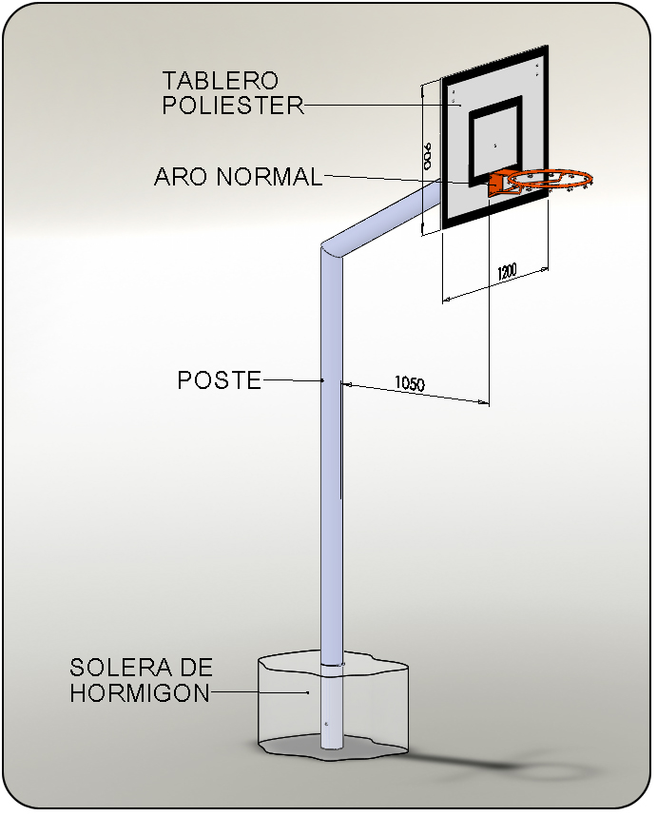

reference | extension | backbooard | width | rim | metallic frame | net
MBFIJ022 | 1050 mm | Methacrylate | 20 mm | Estandard | Yes | Nylon

